Alternate Psyche

Game Design Document

With the introduction of the Machine Intelligence Emancipation Act, thousands of Alternately Intelligent (formerly known as Artificially Intelligent) machines were given their rights and freedoms.

This new demographic of citizens who had previously been taken care of by their owners – be those corporate or otherwise - now were responsible for their own basic necessities.

Where once a malfunctioning android would simply get decommissioned and shut down, now they did not, continuing to live and work with their malfunction.

Alternate Intelligence Psychology was now a field of great interest for many, and in an office near the center of Cyber City AI could find counselling and help for their malfunctions…

Table of Contents:

Game Play

* Core Game Loop
* Scenes
* Characters
* Shop Items

Art Style

* Artistic References
* Game References

Money Plan

Game Play:

**Core Game Loop:**

In Cyber Psychology you play as an Alternate Intelligence Psychologist who works in Cyber City. Newly graduated, you find a huge demand for your services, and your first day in the office you already have a list of patients. As you work with your patients you get to know them, their lives and their malfunctions, and it will be up to your with your dialogue and treatment choices to help your patients learn how to cope or possible fix their malfunctions. Treatment options will fall under 4 schools of thought around therapy, being:

Psychodynamic

Existential-humanistic

Behavioral

Cognitive

You will need to gain money in order to fulfill the needs of your patients. The money you receive each month will reflect how successful you are as a therapist. You receive a government stipend for your work, which is based on your turn around with your patients. You receive a bonus when you pronounce an AI cured, but will receive docked pay if that AI returns in the future. You don’t receive docked pay for keeping patients for long amounts of time, but eventually they will either stop coming, which will dock you pay, or you will need to pronounce them cured, or recommend them to a specialist who will recode their brains to get rid of the malfunction.

**Scenes:**

* Apartment

Your apartment is your preparation area. It is where you can review notes from sessions with your patients, view who you are seeing in the following week, purchase therapy items, etc.

Purchasing items will change what you are able to prescribe to your patients, so listening to your patients and coming up with a treatment plan early on will help guide your purchase decisions, since you will only have so much money per month.

* Office

Your office is where you will have the bulk of your gameplay and interaction. This is where your patients visit you, you talk with them, and you make dialogue and treatment decisions in the moment. When you start the game you will have limited treatment options, only having a few basic executables to prescribe and nothing else. By the end of the game you should have a stock of executables and treatment devices at your exposal.

**Characters / Patients:**

Mrv-N:

A simple workforce android, with a replacement left arm. He hasn’t let himself go to sleep or shut down for some time, and it’s starting to effect his processor functioning.

D-An:

She works as a surgeon and is struggling with the loss of a patient. She performed many surgeries on this patient, and in the end the patient died and D-An now feels each surgery was a failure, and that she shouldn’t be a surgeon anymore after more than a dozen failed surgeries.

Bek-E:

Bek-E keeps losing parts of her memory. She will wake up and not remember what she did the previous day. It is as if her memory recording function isn’t properly saving her experience to her long term memory banks.

B1-LL:

Self-destructive tendencies. He breaks himself apart to get attention at AI hospitals. We now have him under strict surveillance here so that he doesn’t continue that behavior. He may need serious reprogramming as a last resort.

St3v3:

St3v3 is a former law enforcement officer that was shot in the line of duty. The bullet took out a piece of his neural network and his communication cortex is screwed up, his words coming out jumbled and mixed up.

B3n:

B3n has a over-clock addiction, and his processor is failing. He needs to stop his usage and build his normal processor speed back up.

Pau1:

Pau1 was an actor that built several personalities for characters he played on TV. Now these personalities all fight to take over.

J3ss-E:

Art Style:

Artistic References:

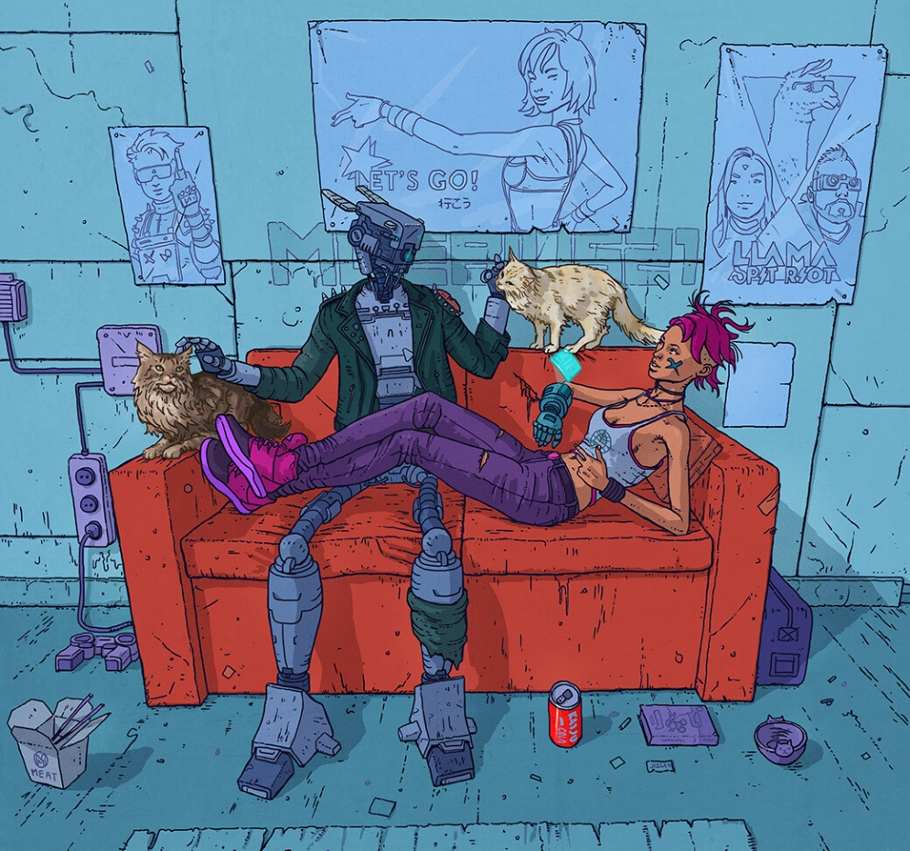Alexander Gioiosa

Craig Paton

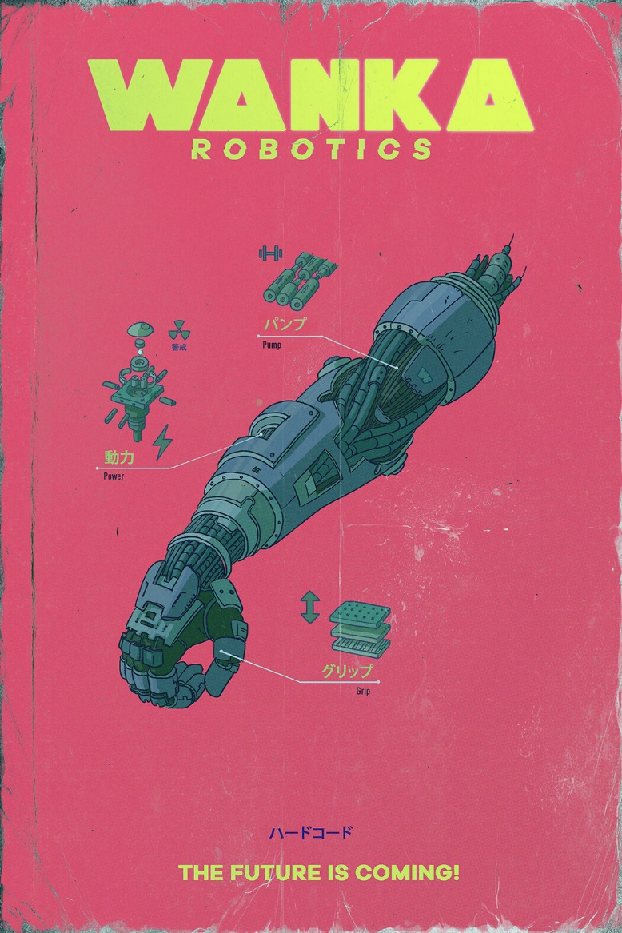

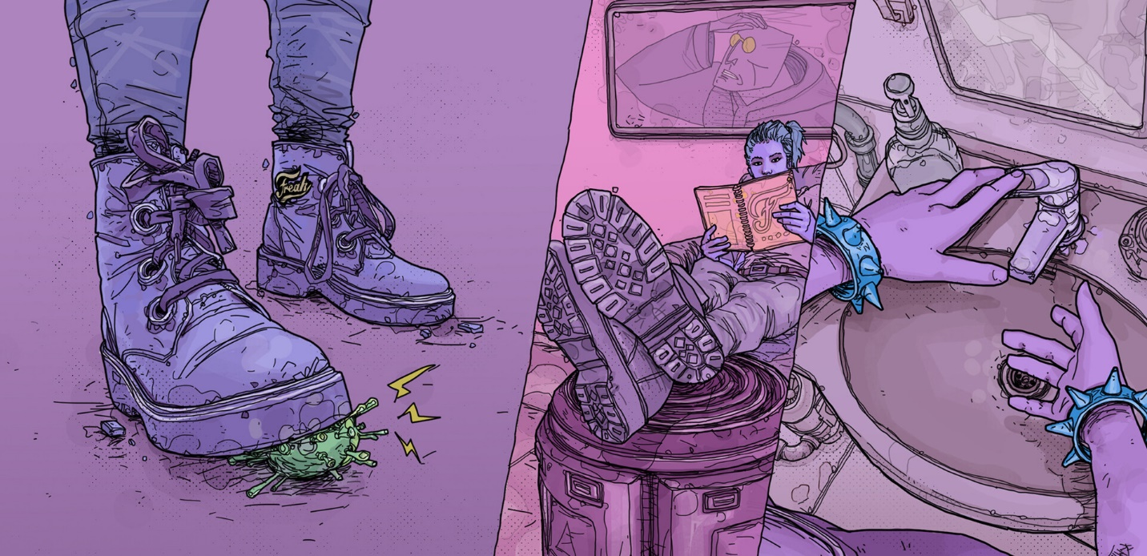

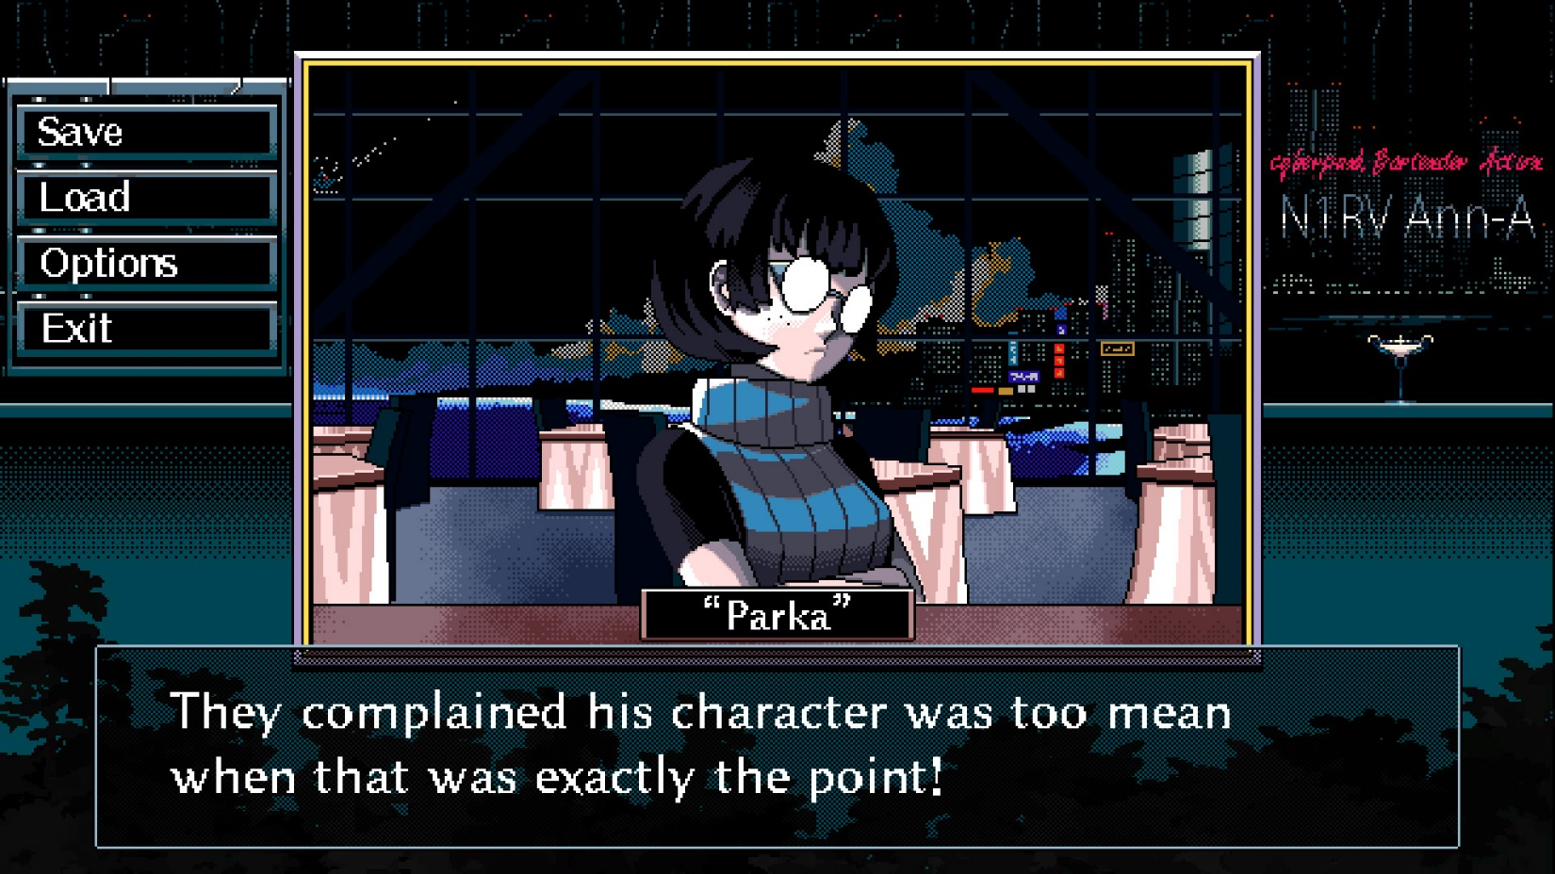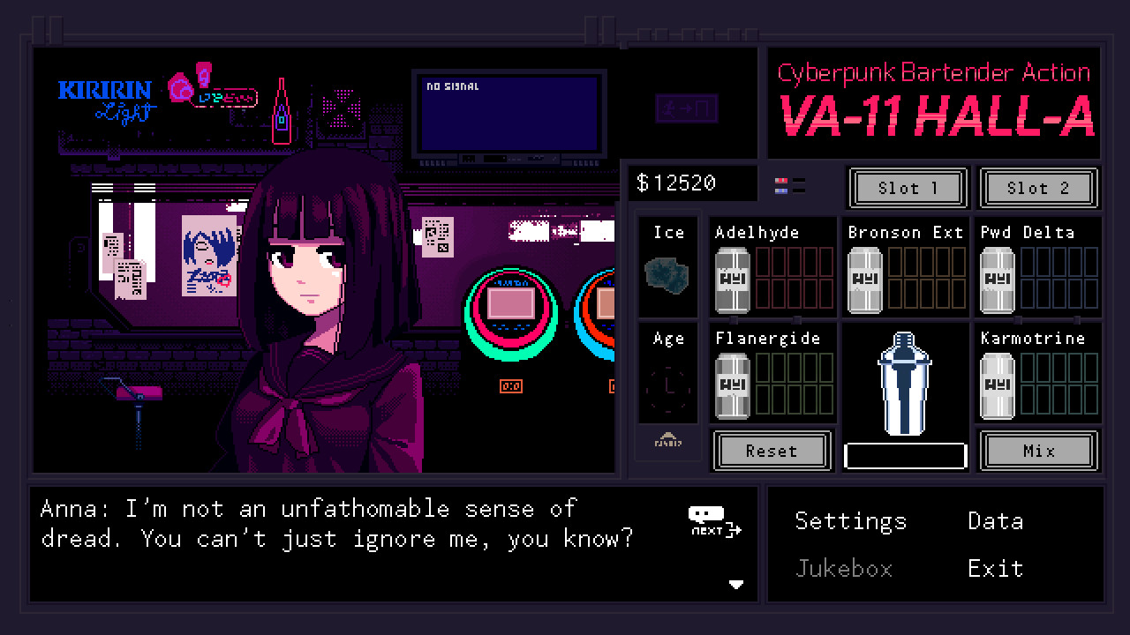Game References:

Therapy Resources:

[Psychotherapy video crash course](https://www.youtube.com/watch?v=6nEL44QkL9w)

Money Plan